Setup Manufacturing Advance Supply Chain Planing.

Responsibility

OPM Material Planer -> Material Planing -> Setup -> Paramerters

Organization (Produksi)

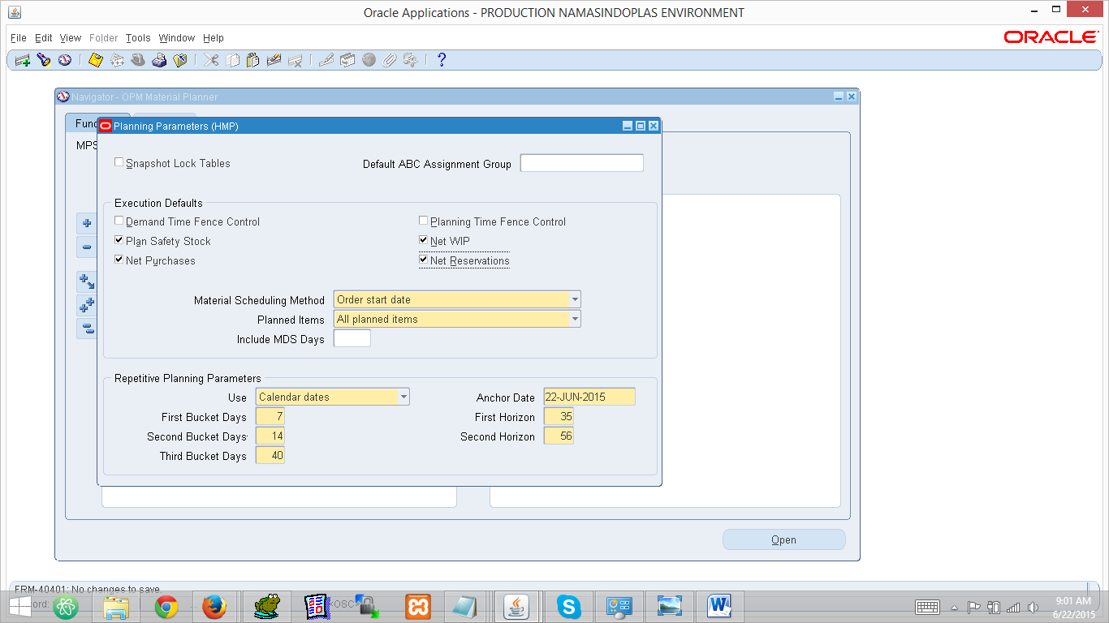

Setup Planing Instance   
Responsibility

Advance Planning Administrator -> Admin -> Instance

Untuk instance tidak ada yang di tambahkan hanya tambahkan organization produksi pada plant baru

Organization -> Masukkan Organization Produksi Plant Baru.

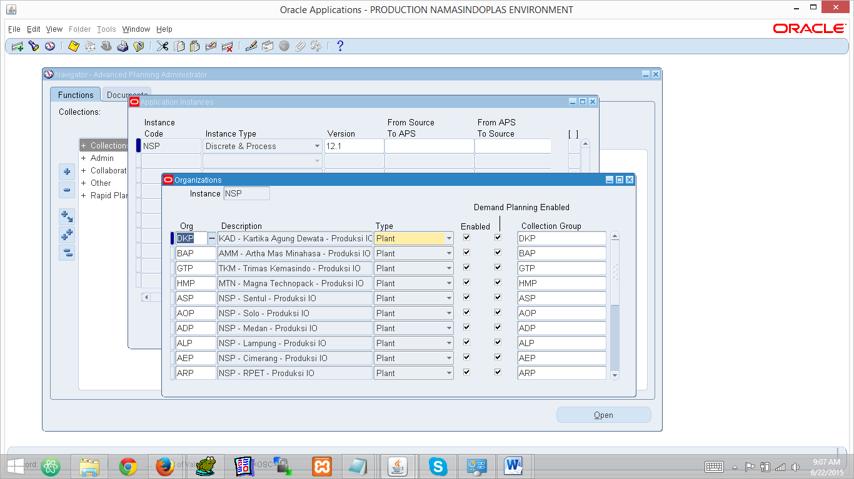

Jalankan Concurrent ‘Refresh Collection Snapshots’

Dengan Parameter berikut

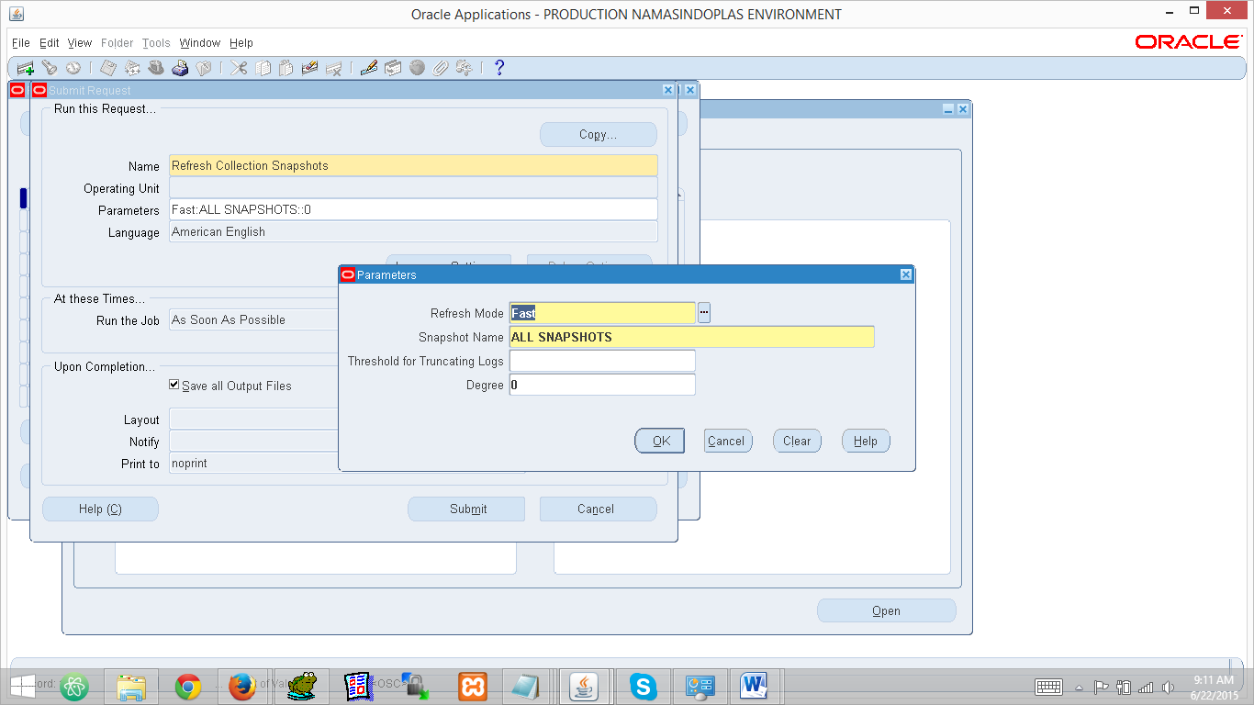

Untuk running pertama akan terjadi error, lalu jalankan concurrent yang sama dengan parameter berikut ini:

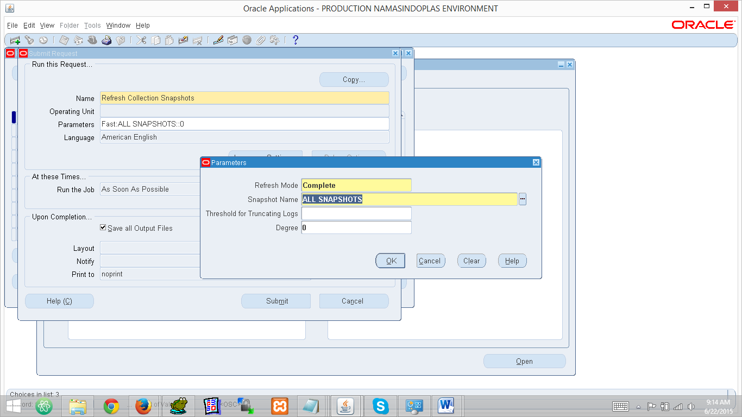

Jalankan Concurrent ‘Standart Collection’  
Responsibility

Advanced Planning Administrator -> Collections -> Oracle System -> Standart Collection

Untuk Segment Diisi sesuai dengan data di bawah ini :

*Jika running untuk plant baru maka pada parameter collection group di pilih OU Produksi plant tsb.

| Planning Data Pull parameters | |
| --- | --- |
|  | |
| **Instance** | NSP |
| **Collection Group** | All |
| **Number of Workers** | 2 |
| **Timeout (Minutes)** | 180 |
| **Purge Previously Collected Data** | Yes |
| **Collection Method** | Complete Refresh |
| **Analyze Staging Tables** | No |
| **Approved Supplier Lists (Supplier Capacities)** | Yes, replace all values |
| **ATP Rules** | Yes |
| **Bills of Materials/ Routings/Resources** | Yes |
| **Bill of Resources** | Yes |
| **Calendars** | Yes |
| **Demand Classes** | Yes |
| **End Item Substitutions** | Yes |
| **Forecasts** | Yes |
| **Items** | Yes |
| **Key Performance Indicator Targets** | Yes |
| **Master Demand Schedules** | Yes |
| **Master Production Schedules** | Yes |
| **On Hand** | Yes |
| **Planning Parameters** | Yes |
| **Planners** | Yes |
| **PO Receipts** | Yes |
| **Projects/Tasks** | Yes |
| **Purchase Orders/Purchase Requisitions** | Yes |
| **Reservations** | Yes |
| **Resources Availability** | Collect Existing Data |
| **Safety Stock** | Yes |
| **Sales Orders** | Yes |
| **Sourcing History** | Yes |
| **Sourcing Rules** | Yes |
| **Subinventories** | Yes |
| **Supplier Responses** | Yes |
| **Suppliers/Customers/Orgs** | Yes |
| **Transportation Details** | Yes |
| **Unit Numbers** | Yes |
| **Unit of Measure** | Yes |
| **Use Company Association\*** | Create Users and Enable User Company Association |
| **User Supplies and Demands** | Yes |
| **Work in Process** | Yes |

**\* NOTE padaUse Company Association: Secaradefault value = ‘No’. Ubah value ke‘Create Users and Enable User Company Association’ untukinitial data collection yang menggunakanComplete Refresh method**

| Planning ODS Load parameters | |
| --- | --- |
|  | |
| **Instance** | NSP |
| **Timeout (Minutes)** | 180 |
| **Number of Workers** | 3 |
| **Recalculate Sourcing History** | Yes |
| **Purge Sourcing History** | No |
| **Refreshed Collected Data in APCC Repository** | No |

Setting Define Organization Security for planning Responsibility

Add organization produksi di

Advance Supply Chain Planner dan Di responsibility PPIC

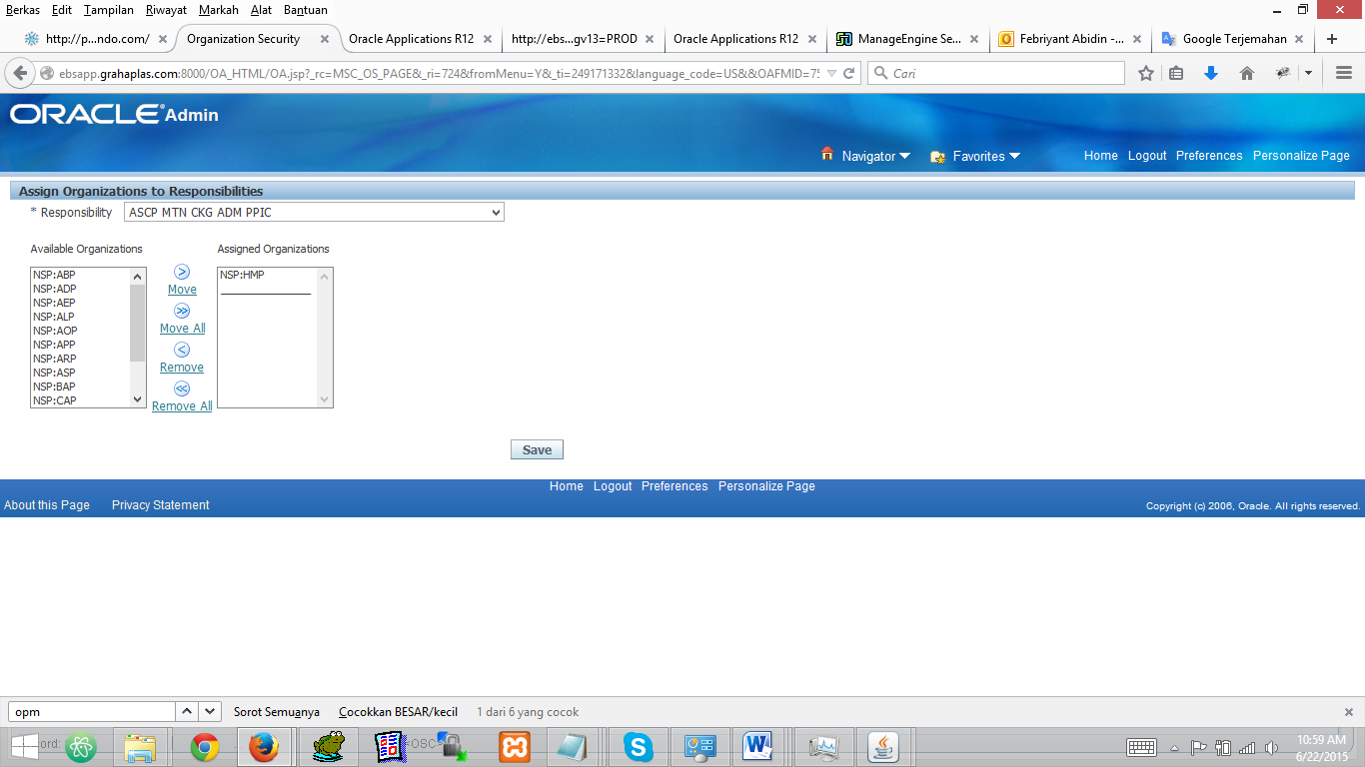

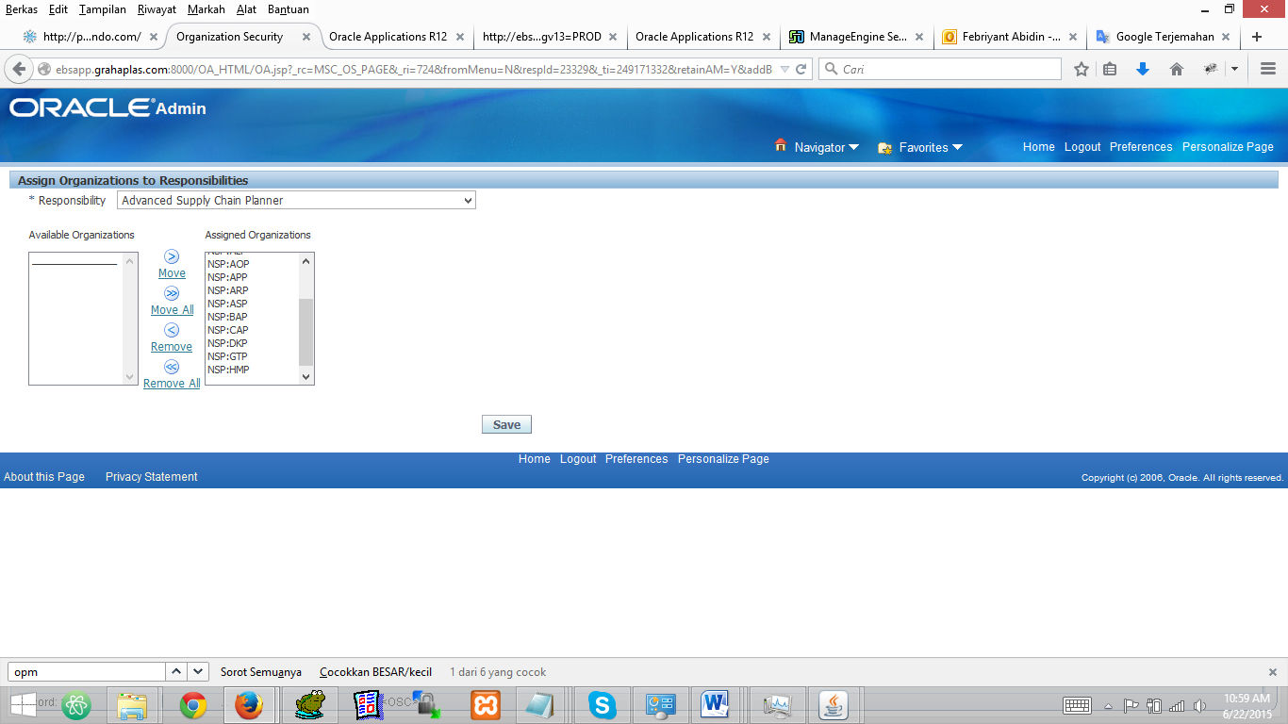

Setup Paramater   
Responsibility

Advanced Supply Chain Planner -> Setup -> Parameters

